

**Tribhuvan University**

**Faculty of Humanities and Social Science**

**File Storage & Management System**

**A Project Report**

**Submitted To**

Department of Computer Application

Butwal Kalika Campus

***In partial fulfillment of the requirements for the Bachelors in Computer Application***

**Submitted By**

Rahul Thapa [Reg. No. 6-2-1055-21-2018]

Jayanti Shrestha [Reg. No. 6-2-1055-07-2018]

Under the Supervision of

**Bhuban Panthee**



**Tribhuvan University**

**Faculty of Humanities and Social Science**

**Butwal Kalika Campus**

**Supervisor’s Recommendation**

I hereby recommend that this project report prepared under my supervision by **Rahul Thapa** and **Jayanti Shrestha** entitled “**File Storage & Management System**” in partial fulfillment of the requirement for the degree of Bachelor in Computer Application of Tribhuvan University by processed for evaluation.

…………………………………..

Mr. Bhuban Panthee

**Lecturer**

**Project Supervisor**

**Butwal Kalika Campus**

**Letter of Approval**

# Student’s Declaration

We hereby declare that project report entitled “**File Storage & Management System**” submitted in the partial fulfillment of the requirement for Bachelor’s degree of Bachelor in Computer Application of Tribhuvan University, is our original work and not submitted for the award of any other degree, diploma, fellowship, or any other similar title or prize.

**……………………….**

**Rahul Thapa**

**[6-2-1055-21-2018]**

**……………………….**

**Jayanti Shrestha**

**[6-2-1055-07-2018]**

# Supervisor Log File

**Name of Supervisor: Mr. Bhuban Panthee**

**Name of Project: File Storage & Management System**

|  |  |  |  |  |
| --- | --- | --- | --- | --- |
| **Date** | **Session** | **Method of Supervision** | **Feedback** | **Signature** |
| 2023-05-07 | 1hr:30min | In-Person | Discussed project scope and objectives. |  |
| 2023-05-15 | 1hr:30min | In-Person | Reviewed project timeline. |  |
| 2023-05-24 | 1hr:30min | In-Person | Discussed database design. |  |
| 2023-06-03 | 1hr:30min | In-Person | Reviewed coding progress. |  |
| 2023-06-12 | 1hr:30min | In-Person | Clarified documentation requirements. |  |
| 2023-06-21 | 1hr:30min | In-Person | Emphasized clear documentation. |  |
| 2023-07-02 | 1hr:30min | In-Person | Reviewed final project draft. |  |
| 2023-07-10 | 1hr:30min | In-Person | Discussed presentation preparations. |  |

**……………………….**

**Jayanti Shrestha**

**[6-2-1055-07-2018]**

**……………………….**

**Rahul Thapa**

**[6-2-1055-21-2018]**

# Acknowledgement

Our forthright gratefulness goes to our supervisor **Mr. Bhuban Panthee**, Lecturer, Department of Computer and Social Science, Butwal Kalika Campus, for wholehearted support and providing us the opportunity to undertake this project. We would like to extend our sincere gratitude to **Mr. Vishnu Neupane**, and **Mr. Nirmal Aryal**. Lecturers, Department of Computer Science, Butwal Kalika Campus, for their kind and co-operative support, valuable time, and guidance as well as suggestions. Their useful suggestions for this whole work co-operative behavior are sincerely acknowledged.

We are also thankful to **Mr. Aashish Neupane**, HOD Department of Computer Application, Butwal Kalika Campus for his support.

At the end, we would like to express our sincere thanks to all our friends and others who helped us directly or indirectly during the preparation of this project.

Thanking You,

Rahul Thapa [Reg No. 6-2-1055-21-2018]

Jayanti Shrestha [Reg No. 6-2-1055-07-2018]

# Abstract

The “**File Storage & Management System**” will be a web-based application. It will be a form of regular cloud storage as GitHub, GitLab, Box, Dropbox, One Drive, Google Drive etc. which provides user to keep their important data safe and accessible. Our project just focuses about file sharing rather than supporting file versioning, team collaboration, package subscriptions etc. Cloud Storage is a model of computer data storage in which the digital data is stored in logical pools, said to be on "the cloud". It’s a medium to share user’s file to the cloud storage as a backup. The main objective of our project is to save copies of data and files as backup. That’s way, if the original data or file is corrupted, compromised, or destroyed, a backup is available on the cloud with which to recover. Also, all this is available at a much lower cost than if one were to purchase all the physical devices necessary to hold the data.

Table of Contents

Student’s Declaration iv

Supervisor Log File v

Acknowledgement vi

Abstract vii

List of Figures x

List of Tables xi

Abbreviations xii

Chapter 1: Introduction 1

1.1 Introduction 1

1.2 Problem Statement 1

1.3 Objectives 1

1.4 Scope and Limitation 2

1.5 Report Organization 2

Chapter 2: Background Study and Literature Review 3

2.1 Background Study 3

2.2 Literature Review 4

Chapter 3: System Analysis and Design 5

3.1 System Analysis 5

3.1.1 Requirement Analysis 5

3.1.2 Feasibility Analysis 6

3.1.3 Data Modelling 7

3.1.4 Process Modelling (DFD) 8

3.2 System Design 10

3.2.1 Refinement of Class, State, Sequence and Activity diagrams 10

3.2.1.1 File Storage & Management System Class Diagram 10

3.2.1.2 File Storage & Management System State Diagram 11

3.2.1.3 File Storage & Management System Sequence Diagram 12

3.2.1.4 File Storage & Management System Activity Diagram 13

3.2.1.5 File Storage & Management System Component Diagrams 14

Chapter 4: Implementation and Testing 15

4.1 Implementation 15

4.1.1 Tools Used 15

4.1.2 Implementation Details of Modules 15

4.2 Testing 16

4.2.1 Test Case for Unit Testing 16

4.2.2 Test Case for System Testing 17

Chapter 5: Conclusion and Future Recommendations 18

5.1 Lesson Learnt / Outcome 18

5.2 Conclusion 18

5.3 Future Recommendations 18

Appendix 19

References 22

# List of Figures

Figure 3. 1 System ER Diagram 7

Figure 3. 2 System Level 0 DFD 8

Figure 3. 3 System Level 1 DFD 8

Figure 3. 4 System Level 2 DFD 9

Figure 3. 5 System Class Diagram 10

Figure 3. 6 System State Diagram 11

Figure 3. 7 System Sequence Diagram 12

Figure 3. 8 System Activity Diagram 13

Figure 3. 9 System Component Diagram 14

Figure 6. 1 Register Page 19

Figure 6. 2 OTP Verification Page 19

Figure 6. 3 Login Page 20

Figure 6. 4 User Dashboard Page 20

Figure 6. 5 Create Folder Modal 21

Figure 6. 6 Files Page 21

Figure 6. 7 Payment with Khalti 21

# List of Tables

Table 4. 1 Test Case for Unit Testing 16

Table 4. 2 Test Case for System Testing 17

# Abbreviations

CSS Cascading Style Sheets

PHP Hypertext Preprocessor

HTML Hypertext Markup Language

SRS Software Requirement Specification

DFD Data Flow Diagram

ER Entity Relationship

# Chapter 1: Introduction

## Introduction

While creating a site backup is essential for website’s security, storing your backups in a secure location is equally important. Unfortunately, many business owners rely on outdated storage solutions (such as flash drives or local servers), which can cause a loss of vital data and an increase in unnecessary headaches. That’s why [cloud storage](https://www.wpbackitup.com/blog/storing-your-wordpress-backup-safely) comes in. This stores your data on dedicated servers, and provides unlimited accessibility wherever an internet connection is available, along with an increase in backup file security (given that your files won’t be subjected to local server hacks or data loss).[1]

[File Storage](https://en.wikipedia.org/wiki/Cloud_storage) is a digital storage solution that utilizes multiple servers (typically across multiple locations) to safely store files (such as site backups). In the past few years, cloud storage has grown in popularity and become a direct challenger to local storage, mainly down to the benefits it provides security, accessibility, and no maintenance required.[1]

## Problem Statement

Before the system released, people backed-up their files in their system as a local storage. Users are using their external hard disk, pen drives, and other storage devices to back up their files which needs to buy those devices. Their hard disk may crash at any phase of time and they need to recover their files by paying huge amount of money while recovering. It is much expensive to buy those storage devices and also time-consuming process. Users are unable to access their files without those storage devices. User are unable to access their shared files from different location.

## Objectives

**General Objective**

The main objective of our project is to connect many different devices together to enable the same files to be accessed from any device that uses it.

**Specific Objective**

In Order to achieve the general objective, the following specific objectives are needed.

* To provide cloud-based data security.
* To improve cloud-based file management.
* To implement efficient file retrievals.

## Scope and Limitation

**Scope**

This File Storage & Management System overcomes the loss of data with cloud security. Users do not need to buy storage devices to back up their data. They can access their data at any time at any place with internet connection. It focuses to store and manage their data in the cloud as per the requirement of users. They can upload their sensitive data privately in the cloud storage. Users can share their files to other users according to their needs. In Future, Cloud Storage will play a vital role for storing data in cloud.

**Limitation**

1. Uploading time increases with increase in file size.
2. There is low storage capacity.

## Report Organization

This report is divided into 5 chapters. Each chapter is further divided into different headings. The preliminary section contains the overall information about the project. This section includes abstract, table of contents, list of figures and abbreviations.

**Chapter 1** gives introduction about **File Storage & Management System**. The problem definition, objectives, scope and limitation of this system are discussed.

**Chapter 2** contains background study of the system and literature review section where the research works done in the field of the system are discussed in brief.

**Chapter 3** discusses in detail about the analysis and design of the system. It provides information about the existing system, data collection methods, analysis part, feasibility study and system configuration. It also gives information about overall system architecture, class diagram, use case diagram, sequence diagram and database diagram.

**Chapter 4** gives information about the system development models, implementation techniques, tools used and also test cases of the system for testing.

**Chapter 5** includes the future scope of the project and necessary future recommendations along with conclusion.

# Chapter 2: Background Study and Literature Review

## Background Study

File Storage & Management System is a cloud computing model that stores data on the Internet through a cloud computing provider who manages and operates data storage as a service. It’s delivered on demand with just-in-time capacity and costs, and eliminates buying and managing your own data storage infrastructure. This gives you agility, global scale and durability, with “anytime, anywhere” data access.[2]

File Storage & Management System is purchased from a third-party cloud vendor who owns and operates data storage capacity and delivers it over the Internet in a pay-as-you-go model. These cloud storage vendors manage capacity, security and durability to make data accessible to your applications all around the world. Applications access cloud storage through traditional storage protocols or directly via an API. Many vendors offer complementary services designed to help collect, manage, secure and analyze data at massive scale.[2]

Storing data in the cloud lets IT departments transform three areas:

1. **Total Cost of Ownership:** With cloud storage, there is no hardware to purchase, storage to provision, or capital being used for "someday" scenarios. You can add or remove capacity on demand, quickly change performance and retention characteristics, and only pay for storage that you actually use. Less frequently accessed data can even be automatically moved to lower cost tiers in accordance with auditable rules, driving economies of scale.[3]
2. **Time to Deployment:** When development teams are ready to execute, infrastructure should never slow them down. Cloud storage allows IT to quickly deliver the exact amount of storage needed, right when it's needed. This allows IT to focus on solving complex application problems instead of having to manage storage systems.[3]
3. **Information Management:** Centralizing storage in the cloud creates a tremendous leverage point for new use cases. By using cloud storage lifecycle management policies, you can perform powerful information management tasks including automated tiering or locking down data in support of compliance requirements.[3]

## Literature Review

File Storage & Management System is an opportunity to download files on the server with an ability to access to them from any gadget and any place. Before this innovation appeared, people have been exchanging files in different social networks (like Facebook) and used material storage drives. In fact, they still devote their data to material drives. That is why, currently, not all of the users understand the necessity of using cloud storage. People also usually come across with such a problem, when they put their flash drive in USB input, and the computer does not detect it. Many students failed to show their presentations because of such technical error. Moreover, if the PC finally detects it, you can face the worse problem. A virus that inhabited that computer can move to your flash drive and infect your digital data. But with cloud drives, you can save your education from troubles given by flash drives. It will become and odd object that you will not regret to lose.[4]

However, nowadays, cloud storage is not something new and weird. In daily conversations people mention that they use them for some reasons. But despite everybody knows what it is, the level of users is not very high. Mostly because people are too lazy to download storage app and put their data there. But the price for this laziness can be colossal.[4]

# Chapter 3: System Analysis and Design

## System Analysis

System analysis is a process of collecting and interpreting facts, identifying the problems, and decomposition of a system into its components. System analysis is conducted for the purpose of studying a system or its parts in order to identify its objectives. It is a problem-solving technique that improves the system and ensures that all the components of the system work efficiently to accomplish their purpose. Analysis specifies what the system should do. In this project we decided to make a Mini-Cloud Storage. Where there is user, who can upload their files and can share to others.

### Requirement Analysis

1. **Functional Requirements**

The functional requirements specify the services that the system should provide, how the system should react to particular inputs and how the system should behave in particular situations. In some cases, the functional requirements may also explicitly state what the system should not do. Functional requirements may involve calculations, technical details, data manipulations and processing and other specific functionality that define which a system is supposed to accomplish.

1. **Non-Functional Requirements**

The non-functional requirements of File Storage are as follows:

1. **User Friendly:** The system is user-friendly enough to meet the knowledge and skill of general users. Even the common users who have the knowledge of internet can run this system. The system has simple UI. The system uses simple words and avoids jargons.
2. **Reliability:** The system is effective with a reliable source and tools, so the outcome is reliable. It is highly reliable as it is free of errors.
3. **Performance:** The performance of system is determined by various factors like response time, throughput, resource utilizations etc. And the system should provide the outcome in less time.
4. **Speed:** The response time of the system is fast. During the time of system progress or runtime while using system and viewing the details system doesn’t make user feel as low response time. Overall system is fast.
5. **Availability:** The system is error free and the rate of system failure is very low. The system is available all the time as required by the user.

### Feasibility Analysis

A feasibility study involves whether the project is possible to implement or not. The criteria to judge feasibility are cost required, technical value, delivered etc. A well-designed study should offer a historical background of the business or project, a description of the product or service, accounting statements, details of operations and management, marketing research and policies, financial data, legal requirements and tax obligations.

1. **Technical**

Technical feasibility involves determining whether or not a system can actually be constructed to solve the problem at hand.

1. The required technologies (HTML, CSS, JavaScript & PHP) exist.
2. The database management tool (MySQL Workbench) is technically capable to hold data required to use the new system, and a web server to serve.
3. **Operational**

Operational feasibility asks if the system will work when developed and installed. The following points are taken into account for operational feasibility of the proposed system.

* The system will available for all the users with free of cost.
* It will be an easier way to back up their data on the cloud.

1. **Economic**

The system developed and installed will be good benefit to users. The system will be developed and operated in the existing hardware and software infrastructure. So, there is no need of additional hardware and software for the system.

1. **Schedule**

Time evolution is the most important consideration in the development of project. File Storage can be developed in the considerable amount of time.

### Data Modelling

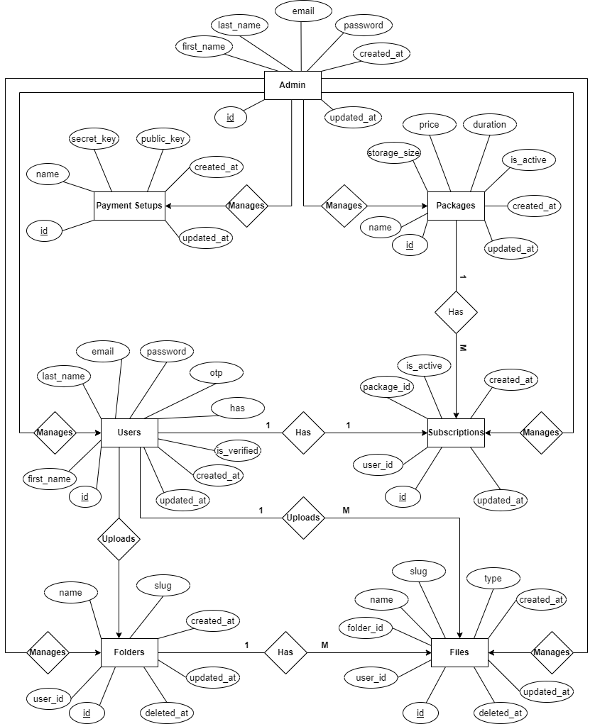

Figure 3. System ER Diagram

### Process Modelling (DFD)

Process Modelling graphically represents the functions, or processes, which capture, manipulate, store, and distribute data between a system and its environment and between components of a system. A Data Flow Diagram (DFD) maps out the flow of information for any process or system. It uses defined symbols like rectangles, circles and arrows, plus short text labels, to show data inputs, outputs, storage points and the routes between each destination.

1. **Level 0 DFD**

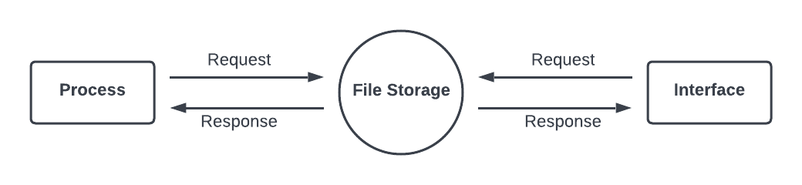

Figure 3. 2 System Level 0 DFD

1. **Level 1 DFD**

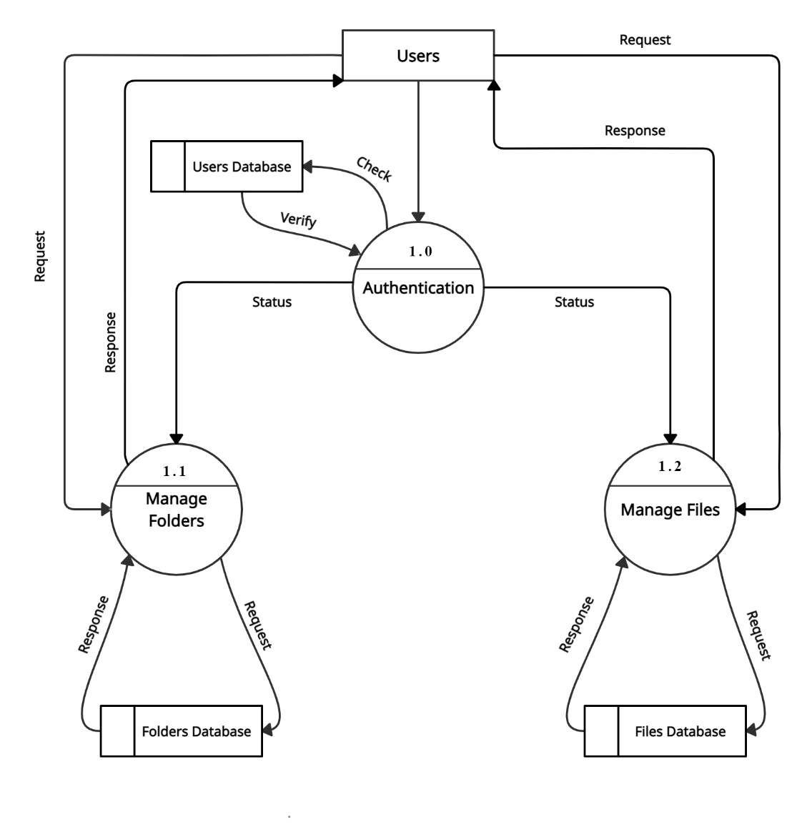

Figure 3. 3 System Level 1 DFD

1. **Level 2 DFD**

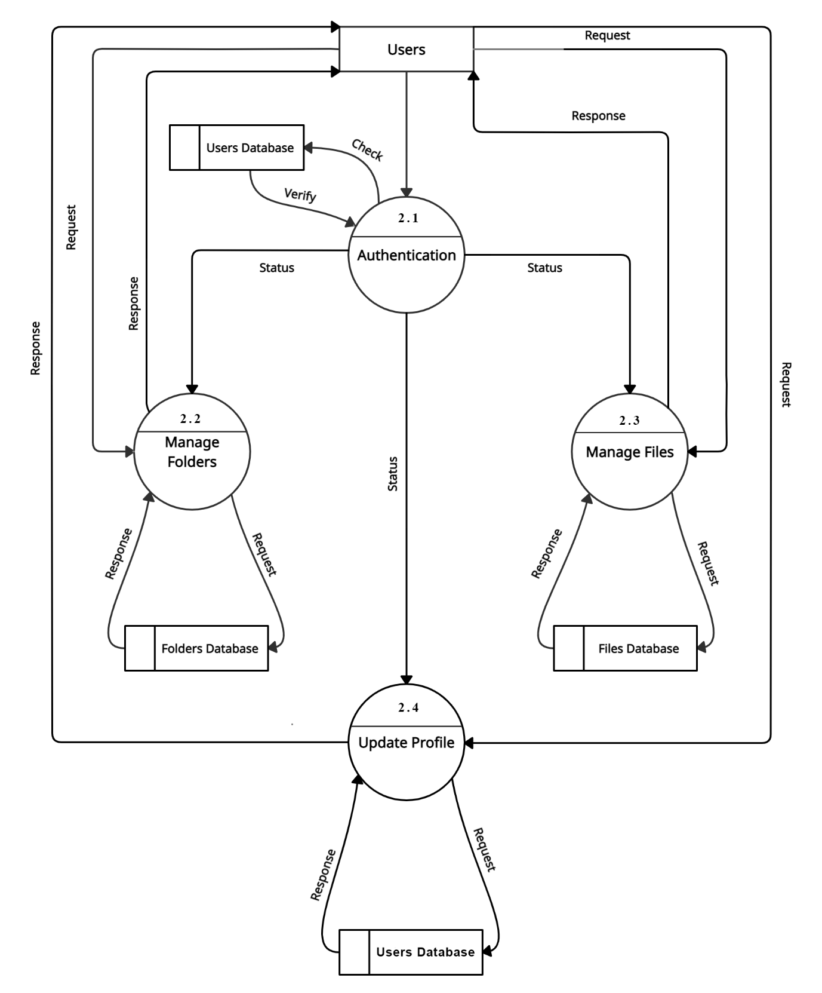

Figure 3. 4 System Level 2 DFD

## System Design

System design is the process of designing the elements of a system such as the architecture, modules and components. It is the phase where the SRS document is converted into a format that can be implemented and decides how the system will operate. The purpose of the system design process is to provide sufficient detailed data and information about the system and its system elements to enable the implementation consistent with architectural entities as defined in models and views of the system architecture.

### Refinement of Class, State, Sequence and Activity diagrams

### File Storage & Management System Class Diagram

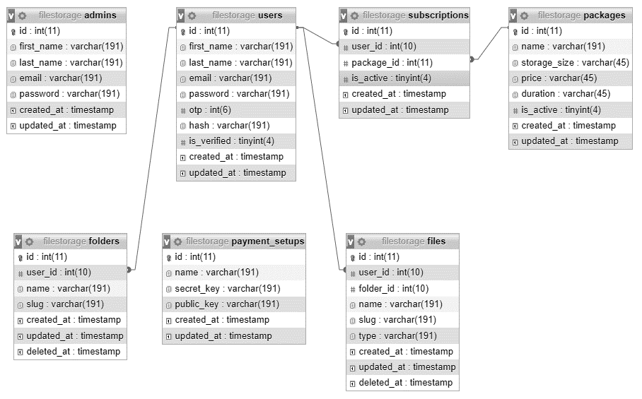

Figure 3. 5 System Class Design

### File Storage & Management System State Diagram

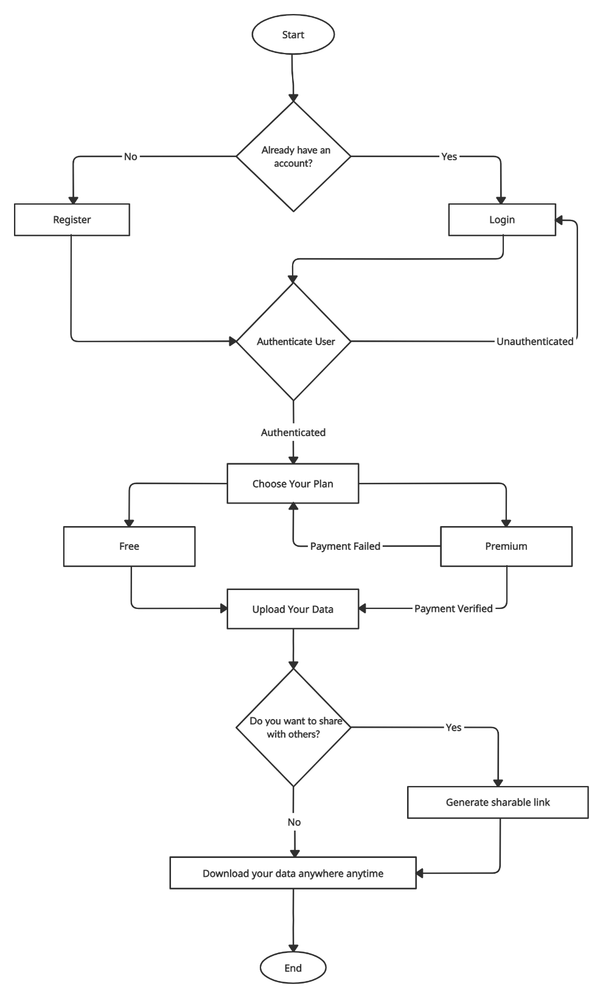

Figure 3. 6 System State Diagram

### File Storage & Management System Sequence Diagram

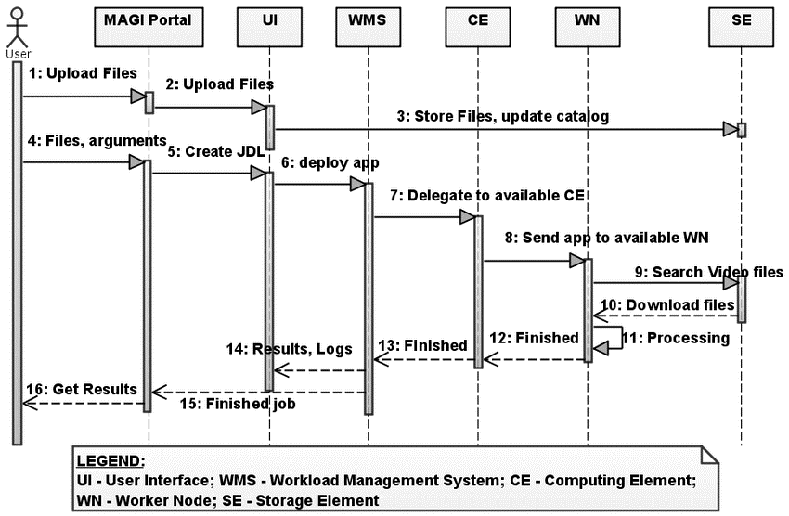

Figure 3. 7 System Sequence Diagram

### File Storage & Management System Activity Diagram

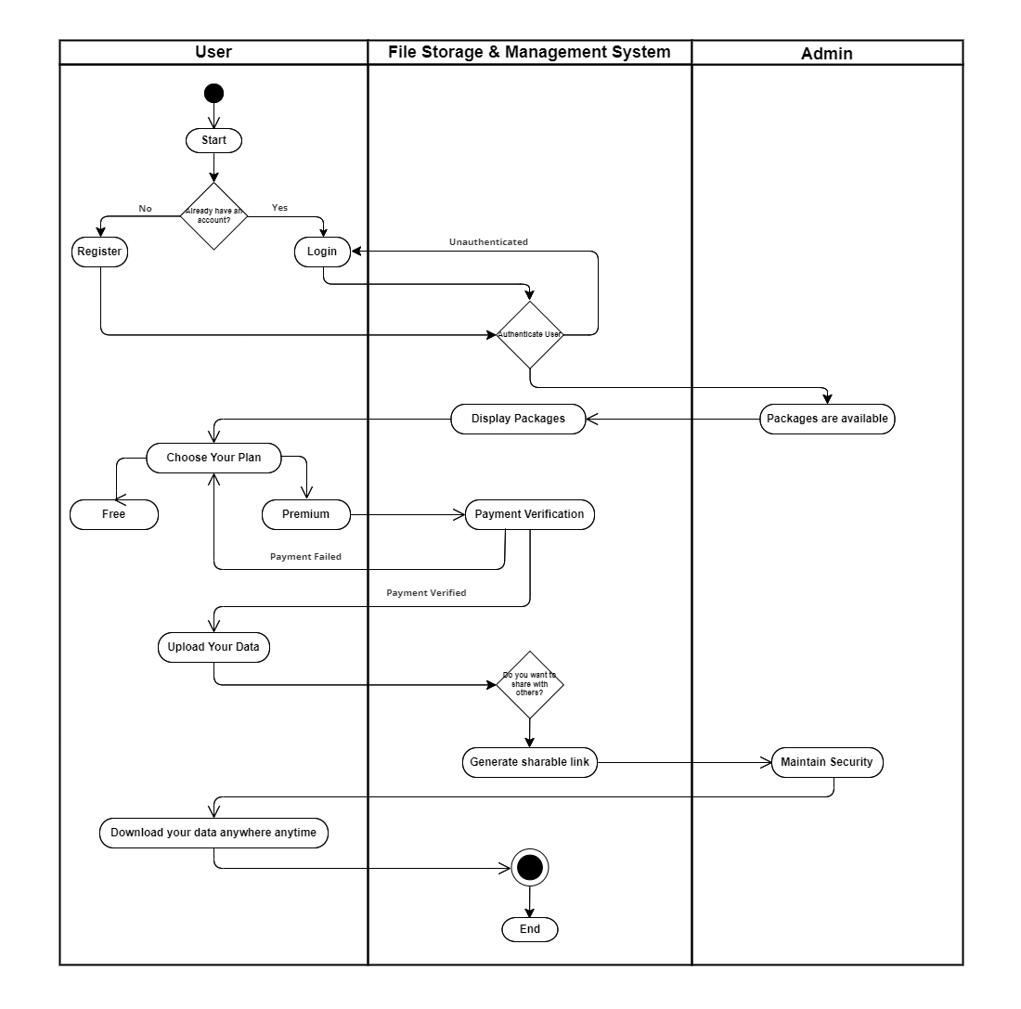

Figure 3. 8 System Activity Diagram

### File Storage & Management System Component Diagrams

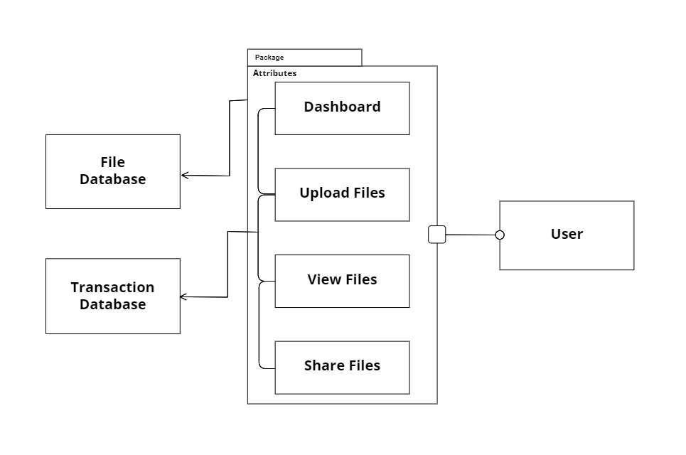

Figure 3. 9 System Component Diagram

# Chapter 4: Implementation and Testing

## Implementation

System implementation specifies how the system is installed, operated and maintained. It also ensures that the system meets the quality standards. System implementation is the test program that exercises the complete system in its actual environment to determine its capabilities and limitations which also demonstrates that the system is functionally operative, and is compatible with the other subsystems and supporting elements required for its operational deployment.

### Tools Used

* Editor: Visual Studio Code
* Front End Development Tools: HTML, CSS, JavaScript
* Back End Development Tools: PHP
* Database: MYSQLI
* Local Server: Xampp Server
* CASE Tools used for development Documentation: MS-Word Figures
* Diagram: Creately, Gantt Chart

### Implementation Details of Modules

The entire project mainly consists of 3 modules.

**User**

* Signup and Login
* Manage Profile
* Forgot or Reset Password
* Logout

**Folder**

* Create, Modify, View and Delete Folder
* Share Folder

**File**

* Create, Modify, View and Delete File
* Download File
* Share File

## Testing

Testing is the process carried out on software to detect the difference between its behavior and the desired behavior as stipulated by the requirements specifications. Testing is advantageous in several ways. Firstly, the defects found helps in the process of making the software reliable. Secondly, even if the defects found are not corrected, testing gives an idea as to how reliable the software is. Thirdly, over time, the records of defects found reveals the most common type of defects, which can be used for developing appropriate preventive measures such as training, proper design and reviewing.

### Test Case for Unit Testing

This test is done to determine the working of the individual modules. The Mini-Cloud Storage includes the various modules that are tested at the development processes.

Table 4. Test Case for Unit Testing

|  |  |  |  |  |  |  |
| --- | --- | --- | --- | --- | --- | --- |
| **Test No.** | **Test Case** | **Precondition** | **Input Data Test** | **Expected Result** | **Actual Result** | **Pass/Fail** |
| 1 | Test if user is able to register | User should not have this account | Correct Email address | User must successfully register | Successfully Registered | Pass |
| 2 | Test if user is not able to register | User should have registered with this account | Correct Email address and correct password | User must not able to register & show error message | Email address already exists. | Pass |
| 3 | Test if user is able to login | User should have registered | Correct Email address and password | User must be successfully logged in | Successfully Logged In | Pass |
| 4 | Test if user is not able to log in | User should have registered | Incorrect G-mail or password | User must not able to login | Invalid Credentials | Pass |

### Test Case for System Testing

The focus of the system testing was to evaluate the compliance of the entire system with respect to the specified requirements. System testing helped in approving and checking the business, functional, technical and any nonfunctional requirements of the application concerning the architecture as a whole. The system testing supported for every aspect of scope in this project.

Table 4. Test Case for System Testing

|  |  |  |  |  |
| --- | --- | --- | --- | --- |
| **Test No.** | **Test case** | **Excepted Result** | **Actual Result** | **Pass/Fail** |
| 1 | Test if after registration the user can have login successful | After registering the user must have log in successful. | The user signs up and the login is successful. | Pass |
| 2 | Test if after login the user gets into own profile page and can update information. | After login the user must get into profile and can update information. | The user login and get into their profile activity and can easily update information. | Pass |
| 3 | Test if after editing the information the change is reflected in the database | The change must be reflected in the database. | The new information is updated in the database | Pass |

# Chapter 5: Conclusion and Future Recommendations

## Lesson Learnt / Outcome

In our “File Storage”, following are expected outcome to those people who are facing problems like file crashing, corrupting, etc.

* User can back-up their files with free of cost at any place and at any period of time.
* User can access their backed-up file.
* User can share their backed-up files with by generating a shareable link.
* User can synchronize their files on different devices.
* User can able to download files using shared link.
* User can able to subscribe storage plan with Khalti Wallet.

## Conclusion

File Storage is developed for storing data in the server which fully meets the objectives of the system for which it has been developed. At first, user needs to register, login and verify on our system. After, login one can create folder in their account and after that user can upload their files by selecting the specific folder in the system. The system has reached a steady state where all bugs have been eliminated. The system is operated at a high level of efficiency and all the users associated with the system understands its advantage. File Storage with a great deal of promise, aren’t designed to be high performing file systems but rather extremely scalable, easy to manage storage systems.

## Future Recommendations

On near future we are planning to develop mobile app also so that users can easily backup and synchronize their files without browsing to website. More payment method will be added for subscribing storage plan like e-Sewa, PayPal, and many more. More storage capacity will be provided to the users on increase in number of users. More security will be provided to the users to keep their files more secure from hackers. Similarly, we are planning to upgrade the system based on the responses and feedback from users.

# Appendix

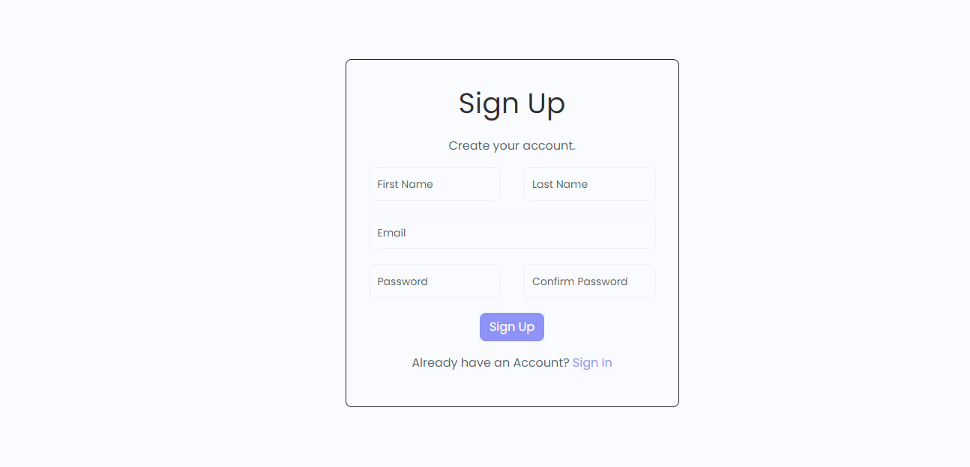

Figure 6. Register Page

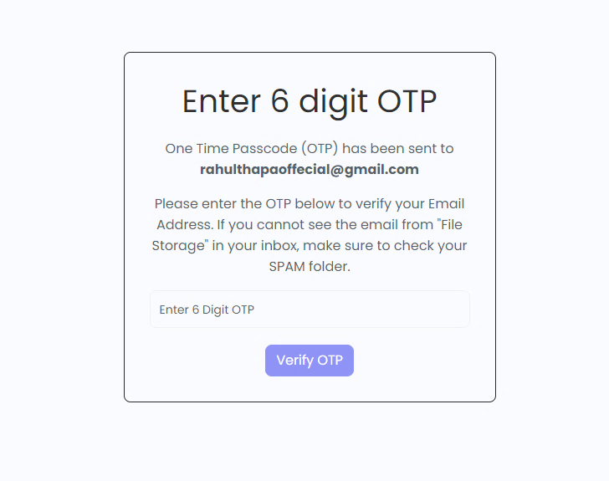

Figure 6. OTP Verification Page

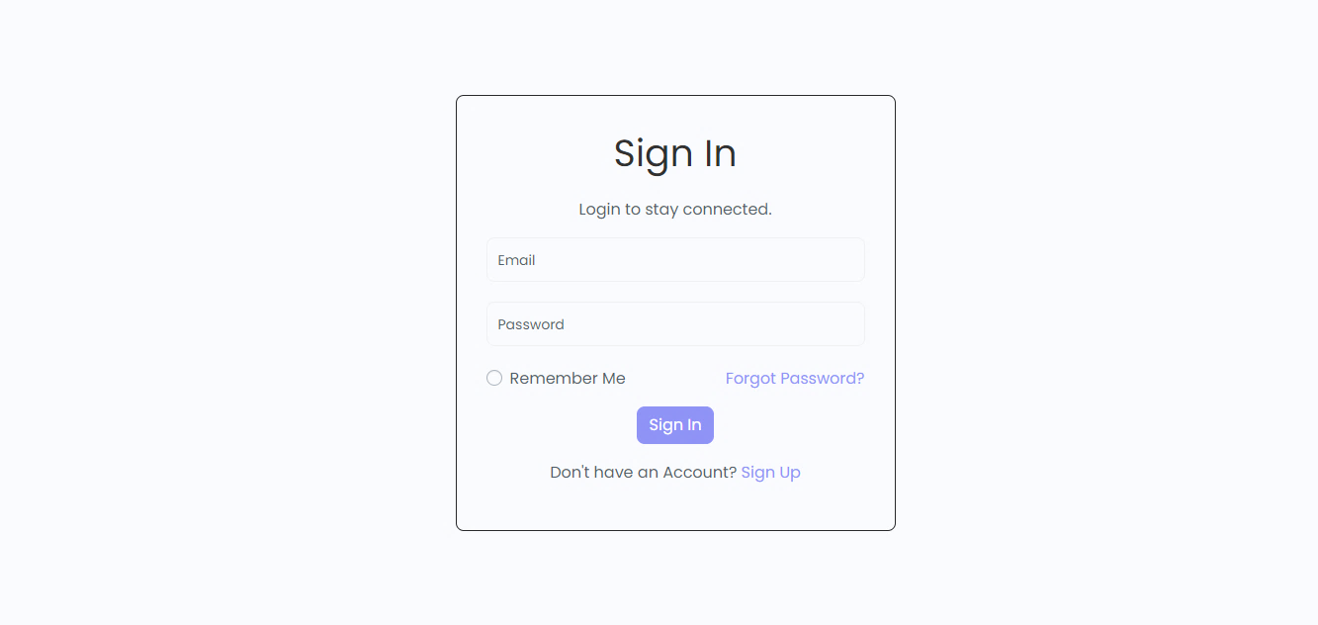

Figure 6. Login Page

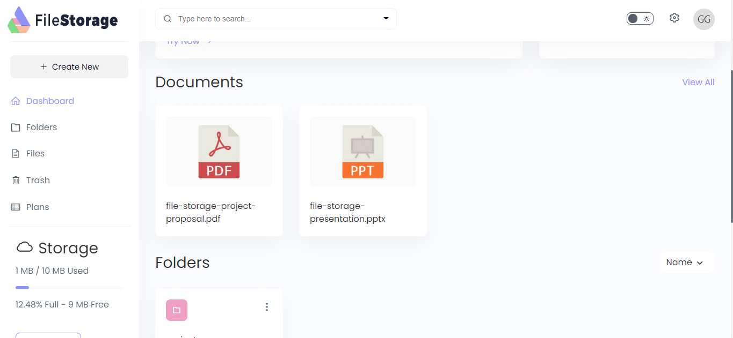

Figure 6. User Dashboard Page

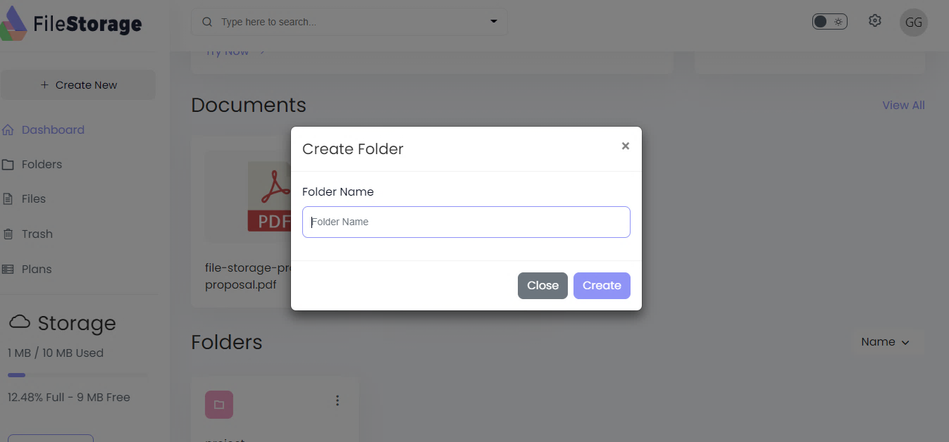

Figure 6. Create Folder Modal

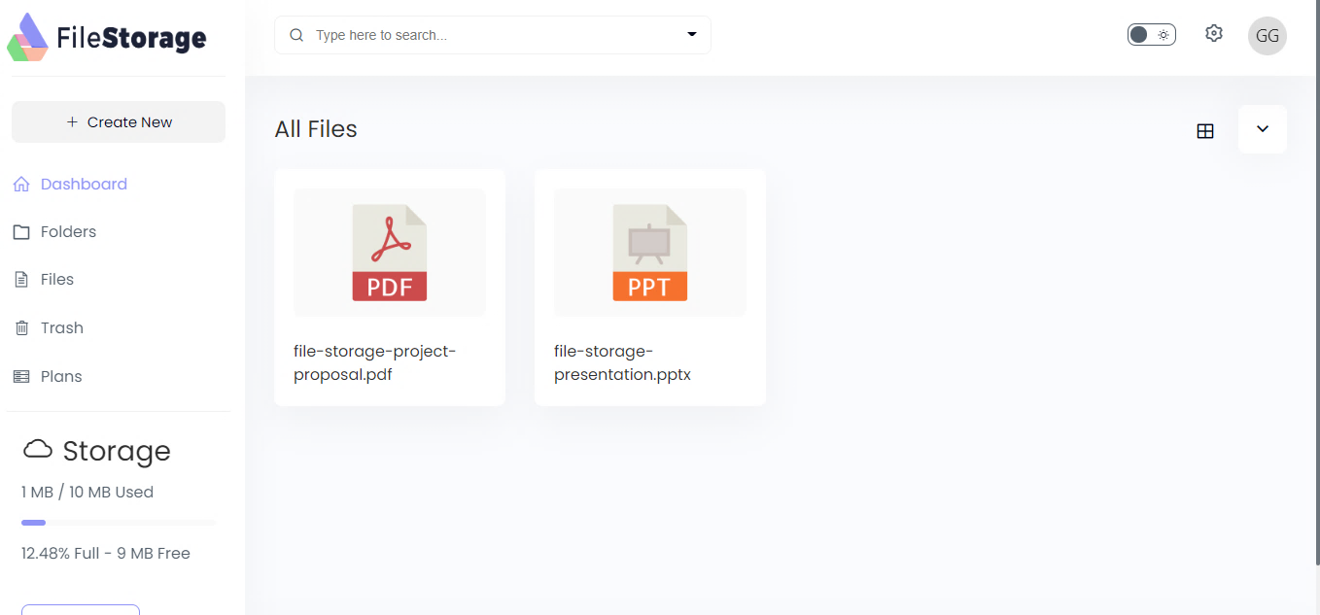

Figure 6. Files Page

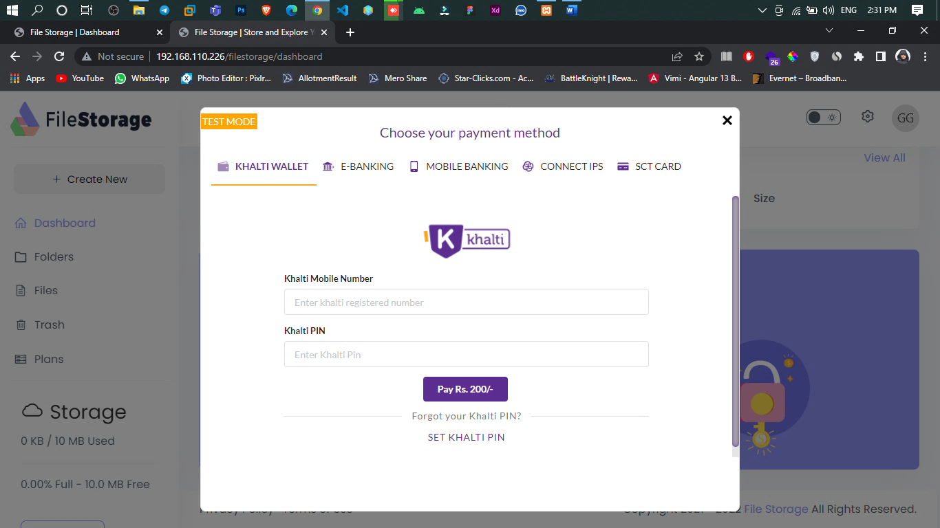

Figure 6. Payment with Khalti

# References

[1] J. Wu, L. Ping, X. Ge, W. Ya, and J. Fu, “Cloud storage as the infrastructure of Cloud Computing,” *Proc. - 2010 Int. Conf. Intell. Comput. Cogn. Informatics, ICICCI 2010*, pp. 380–383, 2010, doi: 10.1109/ICICCI.2010.119.

[2] C. Gong, J. Liu, Q. Zhang, H. Chen, and Z. Gong, “The characteristics of cloud computing,” *Proc. Int. Conf. Parallel Process. Work.*, pp. 275–279, 2010, doi: 10.1109/ICPPW.2010.45.

[3] Z. Diao, Q. Wang, N. Su, and Y. Zhang, “Study on Data Security Policy Based on Cloud Storage,” *Proc. - 3rd IEEE Int. Conf. Big Data Secur. Cloud, BigDataSecurity 2017, 3rd IEEE Int. Conf. High Perform. Smart Comput. HPSC 2017 2nd IEEE Int. Conf. Intell. Data Secur. IDS 2017*, pp. 145–149, 2017, doi: 10.1109/BigDataSecurity.2017.12.

[4] B. Hayes, “Cloud Computing,” *Commun. ACM*, vol. 51, no. 7, pp. 9–11, 2008, doi: 10.1145/1364782.1364786.